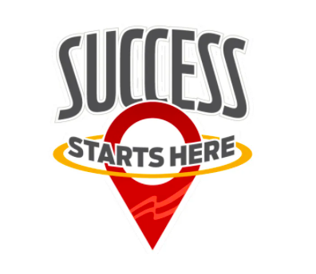

Florida FBLA 2021-22 Calendar

September 15
State and national Fall Conference Registration opens
September 30
Receipt deadline for articles for the fall issue of Florida Communicator
October 4
Receipt deadline for Florida/National Fall Conference Registration
October 20
State and national initial dues deadline for Gold Seal Award
November 4-6
Florida/National Fall Conference, Orlando
November 15
American Enterprise Day
November 16
FBLA District Directors must have district test orders to State Adviser if Competition is in December
November 30
Receipt deadline for articles for the winter issue of Florida Communicator
December 6
FBLA District Directors must have district test orders to State Adviser if competition is in January
December 15
FBLA state and national dues must be postmarked, first-class mail, to be eligible for district, state, and national competition
January 1
Deadline for receipt of intent letters/resumes to run for national office
January 22-23
FBLA-PBL Board of Directors Meeting, TBA
January 30
Receipt deadline for articles for the spring issue of Florida Communicator
February 11
FBLA received date for State Conference registration/hotel reservations/pre-judged materials
February 13-15
Tallahassee Trip for State FBLA and PBL Officers
February 13-19
FBLA/PBL WEEK
February 15
PBL State/National dues postmark deadline to be eligible for State Competition

February 17
PBL received date for State Conference registration/hotel reservations/ pre-judged materials
March 11-14
FBLA Sate Leadership Conference, Hilton Orlando, Orlando
March 17-20
PBL State Leadership Conference, Doubletree SeaWorld, Orlando
April 8-10
FBLA and PBL State Officer Training
April 9 & April 23
FBLA-PBL Pre-NLCs, TBA
June 24-27
PBL National Leadership Conference, Chicago, IL
June 29-July 2
FBLA National Leadership Conference, Chicago, IL

